How To Uninstall Your Audience’s False Beliefs Through Storytelling
Write Your 30-Second Epiphany Bridge Script

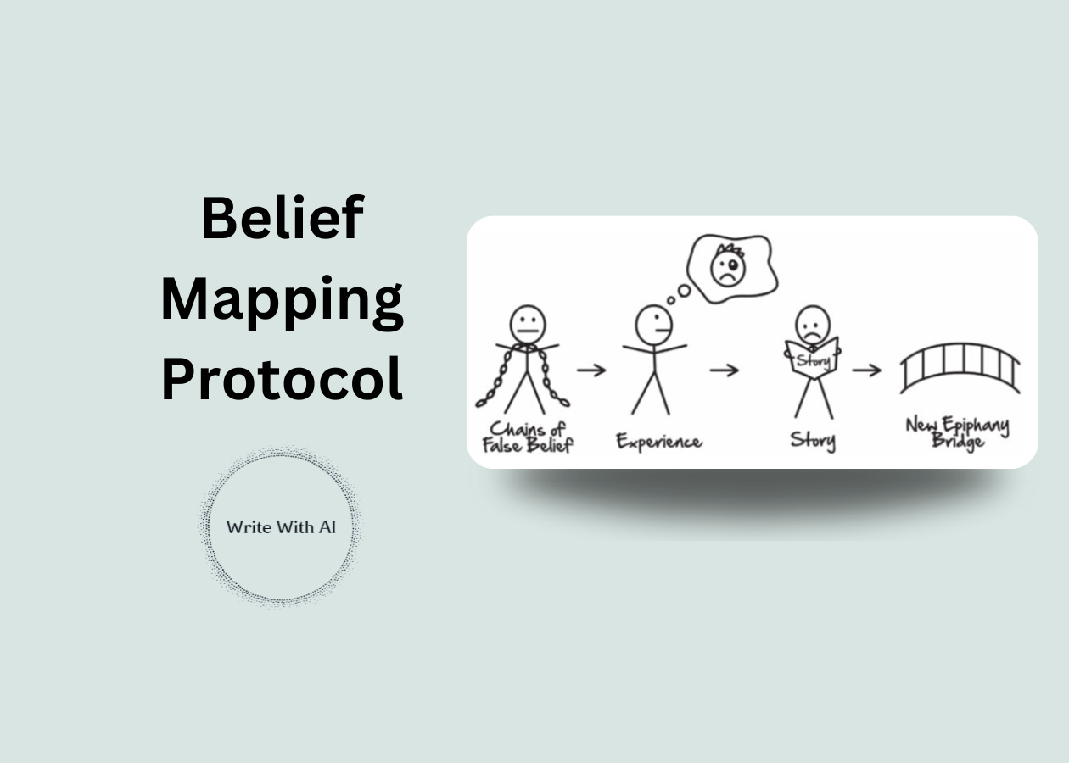

Today, we bring you another guest post from Jim Hamilton.
Jim is a copywriting expert who's written emails for Cole Gordon, Travis Chappell, Justin Moore, and many more in the online space over the last 8 years.
His first guest post on how to write story-driven emails that sell was a big hit.
So today, he’s back to share his Belief Mapping Protocol to help you sell more of your high-ticket offers on sales calls, webinars, and in your emails.
Here's Jim:

Harsh truth:
Low-ticket offers are great for customer acquisition…
But you’re never gonna get rich selling $3 books, $7 toolkits, or $27 courses unless you already have millions of followers.
This is where high-ticket offers come in.
These offer much bigger profit margins for you as the creator and much better results for your customers.
Selling high-ticket requires more persuasion, though.
You can’t just send someone to a checkout page and watch the sales roll in.
Instead, you need to uninstall the hidden mental malware holding them back before presenting your offer.
This mental malware is known as a “False Belief.”
Here’s how it works:
The “False Belief” Paradigm
Russell Brunson is a 9-figure entrepreneur and bestselling author of Expert Secrets.
In the book, he reveals the secret to getting people to buy your high-ticket offer is by uninstalling their false beliefs and then replacing them with new and empowering beliefs.

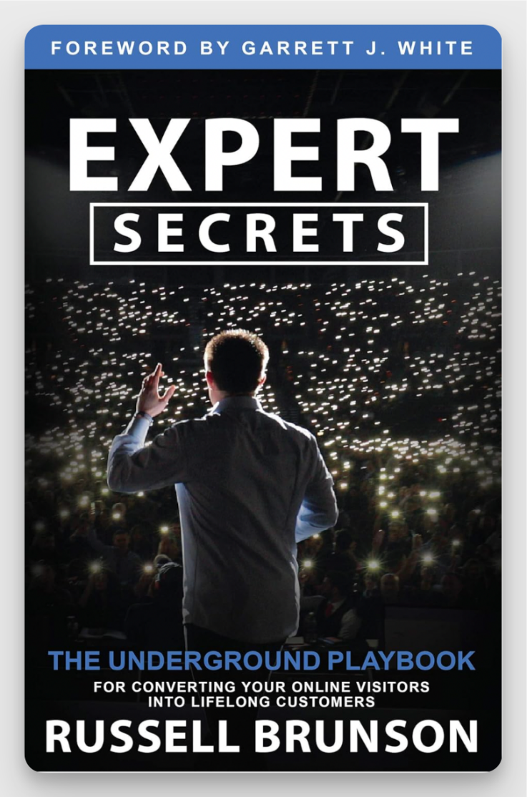

You’ll do this by using the most effective persuasion technique of all time:
Storytelling.
So what are false beliefs, exactly?
They’re simply misconceptions the audience has that prevent them from buying.
And just like a malicious software program on your computer, these mistaken beliefs rewrite your audience’s thoughts and feelings to sabotage any chance they have of success.
False beliefs fall into one of three categories:
1) Vehicle False Beliefs
These are misconceptions about the new method or opportunity you’re presenting. For example: intermittent fasting, TikTok, or paid newsletters.
2) Internal False Beliefs
These are misconceptions about their own ability or other internal forces that will prevent them from succeeding. For example: willpower, creativity, or impostor syndrome.
3) External False Beliefs
These are misconceptions about external forces beyond their control that will prevent them from succeeding. For example: genetics, algorithms, or the economy.
Think of your audience’s False Beliefs like icebergs: 90% of their mass is beneath the surface.
That means if you don’t address them, you’ll never understand why someone didn’t buy.
Luckily though, you’re going to walk away from reading this post with a list of all your audience’s false beliefs. Plus a simple storytelling script to uninstall them so they buy your high-ticket offer.
SIDE NOTE: If you want to see more examples of how you can use storytelling to sell stuff to your newsletter or email list, read my book.
Now let’s get to work.
What You’ll Need to Complete This Belief Mapping Protocol
I’ve found ChatGPT delivers the best results.
So we’re going to use ChatGPT-o1 to complete this exercise.
On top of that, you’ll need to fill in a placeholder for your offer.
This doesn’t need to be super in-depth. In fact, I’ve found sometimes that adding more info makes the outputs worse.
Here’s what I wrote for mine:
The Email Storyselling Playbook - a 66-page book revealing the 4-step formula to convert subscribers into buyers even if you're not a natural writer or storyteller
It’s got:
- Title of the product (Email Storyselling Playbook)
- Description of format (66-page book)
- High-level promise (4-step formula to convert subscribers into buyers)
That’s it.
Start with that and complete the exercise. You always circle back later and flesh out the description if you aren’t happy with the results.
Now let’s dive into the first prompt:
Prompt 1: Map Out False Beliefs
First, we’re going to get ChatGPT to map out the audience’s false beliefs and rank them in order of influence on the buying decision.
This ranked ordering helps you identify which beliefs are most important to uninstall.
I’ve found it’s generally pretty good at this part.
But you can always reorder them before going further if you know better.
As always, we’re going to:
- Assign a role
- Explain the framework
- Show it some good examples
These are the hallmarks of high-quality prompts.
Here’s the full prompt:

Today, you're a world-class marketing analyst with an expertise in researching customer avatars. We’re going to complete an exercise called Belief Mapping. You’ll identify all the False Beliefs my ideal customer has that relates to the product I’m selling. These beliefs are really just stories in disguise, which are based on experiences they’ve had. The purpose of this exercise is to identify the False Beliefs they have and the experiences behind them so we can uninstall them.

You’re going to categorize all False Beliefs into 1 of 3 categories:

1) Vehicle False Beliefs

These are false beliefs the customer has about the new method, strategy, or opportunity we’re presenting.

For example:

Experience: “I tried to sign up my mom for my network marketing company. She was mad.”

Belief: “Network marketing doesn’t work.”

Experience: "I tried fasting but ended up binge-eating at night because I was so hungry."

Belief: “Intermittent fasting just makes you hungrier.”

Experience: “My inbox is too crowded and I hate getting emails.”

Belief: “Email marketing doesn’t work.”

2) Internal False Beliefs

These are false beliefs the customer has about their own ability or other internal forces that will prevent them from succeeding with the opportunity, product, or service.

For example:

Experience: “I tried cutting out carbs so I could lose weight, but it made me miserable.”

Belief: “If I try to lose weight, I’m going to be miserable.”

Experience: “I struggle to post consistently on social media.”

Belief: “I’m too busy to start an email newsletter.”

Experience: “I launched an email newsletter, but nobody joins when I post about it.”

Belief: “I’m not a good copywriter.”

3) External False Beliefs

These are false beliefs the customer has about external forces that will prevent them from succeeding with the opportunity, product, or service.

For example:

Experience: “One of my friends eats carbs, sugar, and junk food all the time and is still skinny. Meanwhile, I can’t seem to lose any weight no matter how hard I try.”

Belief: “I can’t lose weight because I have bad genetics.”

Experience: “I write and publish organic content that I know is valuable, but it gets no reach or engagement.”

Belief: “I can’t grow my audience because of the algorithm.”

Experience: “I’ve never seen anyone else in my market sell their offer with a Google doc.”

Belief: “My market won’t buy from a Google doc.”

Here is the product I’m selling:

[DESCRIBE YOUR OFFER]

Give me the top 5 False Beliefs my ideal customer has for all 3 categories. These should not overlap with each other at all. Each one should be totally unique. And Remember:

Vehicle False Beliefs are about their new method or opportunity we’re presenting, Internal False Beliefs are about their own ability or forces within their control, and External False Beliefs are about external forces beyond their control. Be as specific, detailed, and emotional as possible. Rank them in order from most likely to least likely to influence their buying decision.

Please format each category of False Belief into a table with the Experience on the left-hand side and the False Belief on the right-hand side.

Here are the results I got back:

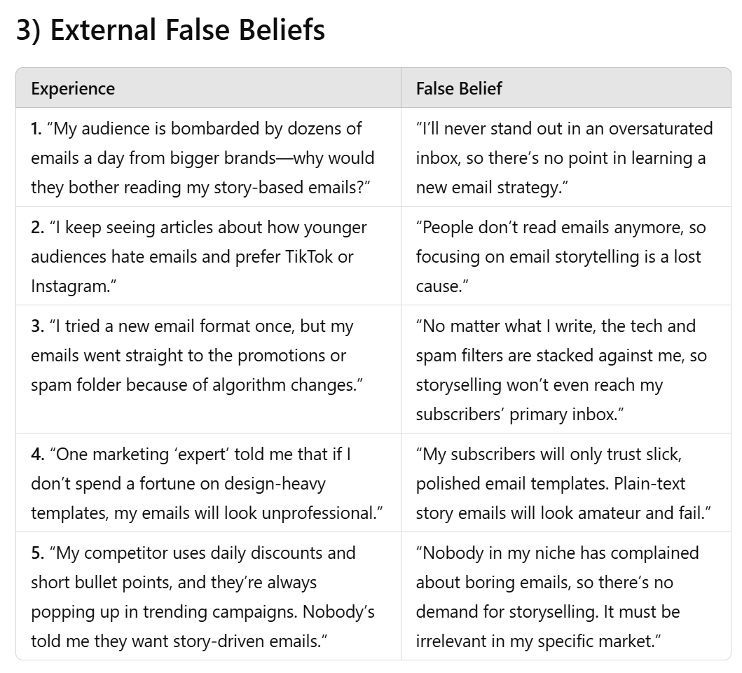

If you feel like the beliefs are wrong based on your knowledge of your audience, try regenerating the response.
You can also reorder them if you need to.
In my case, these are pretty much on the mark.
Once you’re satisfied, move onto the next prompt.
Prompt 2: Generate Story Ideas
Next, we’re going to generate story ideas to target these false beliefs.
This is how you’ll actually uninstall them:
With a personal story of your own, showing how you used to think the exact same thing, followed by the epiphany that led to your new belief.
We’ll include some more examples to make sure ChatGPT knows exactly what we want.
Then ask it to build on the tables it created in the first prompt.
Here’s the full prompt:

Thank you. Now we’re going to come up with new stories I can use to uninstall the customer’s existing False Beliefs and install new empowering beliefs that will lead the customer to buying my product.

Examples:

Customer’s Experience: “I tried cutting out carbs so I could lose weight, but it made me miserable.”

False Belief: “If I try to lose weight, I’m going to be miserable.”

My New Story: “I also thought I’d have to give up things that make me happy to lose weight. But then I learned about ketosis and how I can lose weight by drinking ketones instead of cutting carbs.”

Customer’s New Belief: “I can lose weight without cutting carbs.”

Customer’s Experience: “I joined a network marketing company and they told me to sign up my friends and family, but when I tried, they all got mad at me.”

False Belief: “If I join a network marketing company, I could lose my friends.”

My New Story: “I also thought I might offend my friends if I joined a network marketing company, but then I learned that I can generate leads online. The internet is full of people who want to join my program! So I can grow my team without involving my friends or family.”

Customer’s New Belief: “I can make money by joining a network marketing company without bugging my friends & family.”

Add two new columns to the tables above with My New Story and Customer’s New Belief for each Experience and False Belief you came up with. Be as specific, detailed, and emotional as possible.

Here’s what I got back for each category:

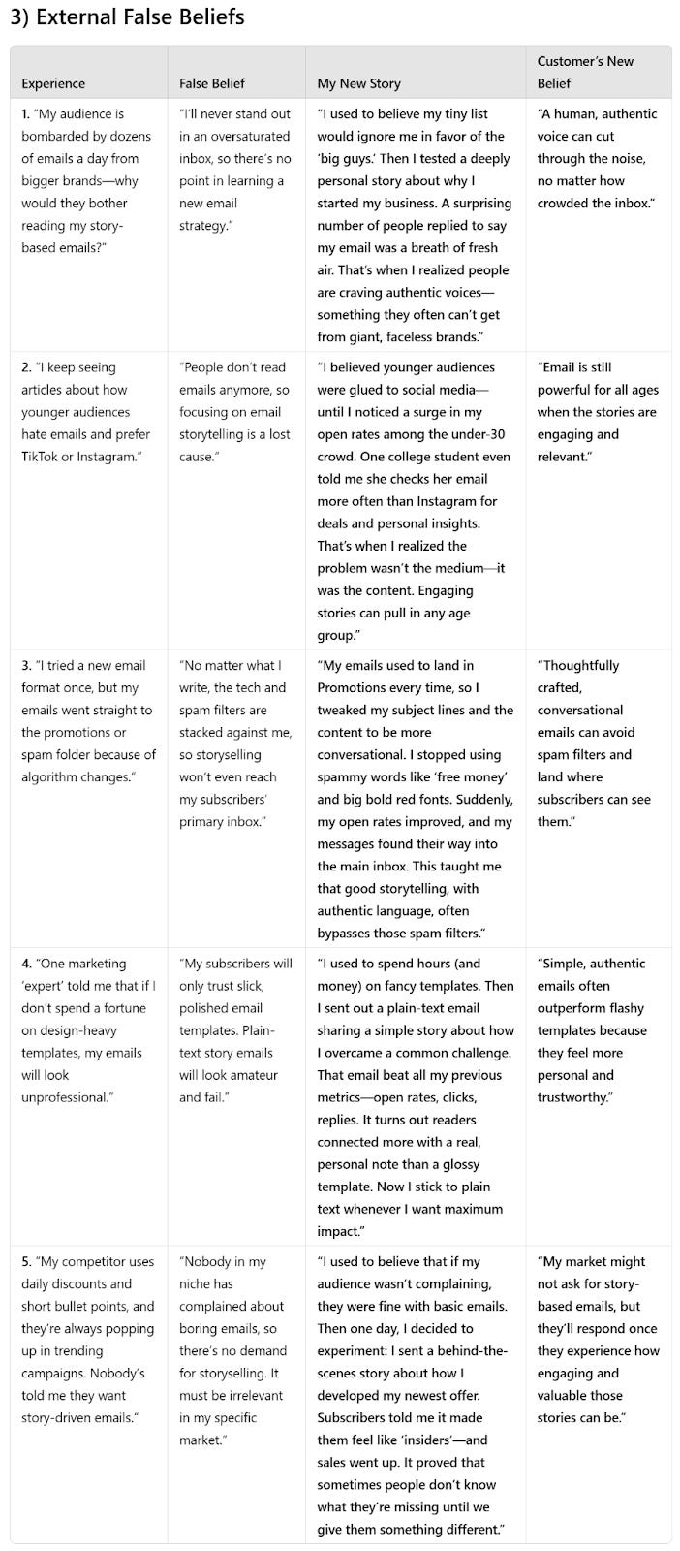

The new stories ChatGPT comes up with may not all apply to you.
But what I’ve found is they often spark my memory so I’m able to come up with a different story to slot in there instead.
Ultimately, what matters most is the new belief you’re installing.
Now that we’ve got a completed list…
It’s time to pick a false belief to uninstall.
Prompt 3: Write Your 30-Second Epiphany Bridge Script
We’ll use a simple storytelling script to seal the deal.
Russell Brunson calls this the 30-Second Epiphany Bridge Script.
The key insight here is showing how you used to share the exact same belief the audience has. This creates connection and opens them up to receive your epiphany without resistance.
Here’s the full prompt:

Perfect! Nice work. Now we’re going to uninstall the false belief that “[INSERT FALSE BELIEF]” and replace it with a new and empowering belief using Russell Brunson’s 30-Second Epiphany Bridge Script.

Here's an example:

"I used to struggle with dog training, thinking it was all about strict discipline. Then, one day, a zookeeper taught me about animal communication. That's when I realized: if we could speak 'dog,' training would be effortless! I created a 'dog dictionary' and audio lessons, and suddenly my classes took off. Now, not only are my own dogs perfectly behaved, but hundreds of my students have transformed their relationships with their pets too."

This incorporates the key elements of the Epiphany Bridge:

- Identifies the false belief (strict discipline in dog training)

- Shares the experience (struggling with training)

- Describes the moment of epiphany (learning about animal communication)

- Explains the new belief (speaking 'dog' language)

- Shares the results (successful classes and transformed relationships)

Now write me a 30-Second Epiphany Bridge script to uninstall the false belief of “[INSERT FALSE BELIEF]” and replace it with a new and empowering belief based on the story you suggested.

The false belief I chose to uninstall is:
“Using personal stories in emails won’t drive sales; it’s too ‘soft’ for real conversions.”
Here’s the Epiphany Bridge Script I got back from ChatGPT:

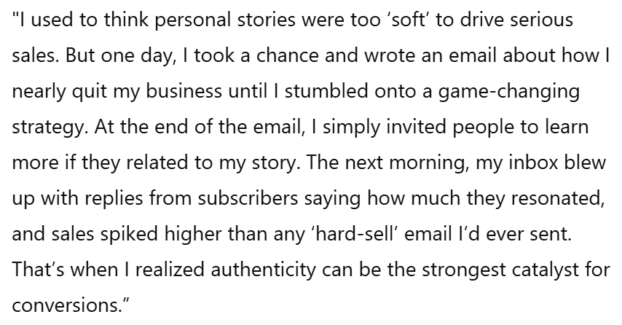

Not too shabby.
As with any AI output, you may need to do some polishing to make it sound more like you.
But all the key puzzle pieces are here to uninstall the false belief and replace it with a new and empowering belief that will lead to high-ticket sales.
These short scripts work great on sales calls and webinars.
Especially when you string together a series of them to uninstall false beliefs from all three categories, going from Vehicle to Internal then External, before presenting your offer.
This is often necessary if you’re selling to a complete stranger.
However, my favorite way to use them is:
Turning each one into a dedicated email and then stringing them together over the course of a product launch or promotional series.
Works like gangbusters if you target the right beliefs.

